Inspection program (example)
DEEP GROOVE BALL BEARING
Ref: IP ABC DGBB- d/m/y
1. STANDARD EMPLOYED
ISO 2859 and relative standards

- INSPECTION CLASSIFICATION
KEY ITEMS | MAIN ITEMS | SUB-ITEMS
HARDNESS | △dmp, Vdp, Vdmp | △Bs, VBs
CRACK | △Dmp, VDp, VDmp | △Cs, VCs
MARKING | Gr | MAGNET RESIDUE
 | Kia, Sia | CHAMFER
 | Kea, Sea | APPEARANCE
 | Sd, SD | ANTI-RUST PACKING
 | ROTATION | SURFACE ROUGHNESS
 | SEALING | MARKING QUALITY
 | NOISE AND VIBRATION

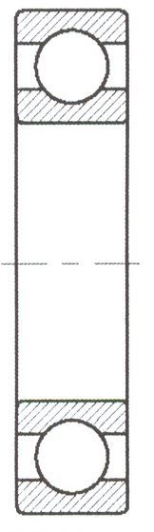
- ACCEPTABLE LEVEL
Key items : AQL 0.1
Main items : AQL 1
Sub items : AQL 4

- SAMPLING SIZE
ISO 2859 Grade 1 (please refer to page 53 of Qua-City catalogue
“Assessment & Inspection Program”).

- SAMPLING TYPE
One time sampling type of normal inspection

- SAMPLING BATCH TREATMENT
  - Inspection passed
Whole item consignment batch passed.

  - Inspection failed
Whole item consignment batch returned to suppliers for 100%
Screening before for another inspection.

Example: for a batch size of 10,000 pcs, sample size=80pcs.
Main items: AC(pass number)=2pcs. Re (failed number)=3pcs.
Sub-items: AC(pass number)=7pcs. Re (failed number)=8pcs.

